Tests, Assignments, and Special Events Calendar
Sr. Sabreen's Grade 1
ifsgrade1.weebly.com
December 2017

Monday | Tuesday | Wednesday | Thursday | Friday
 |  |  |  | 1
4  B O O K F A I R | 5  Monthly Lunch   | 6  Book Character  Dress-Up Day  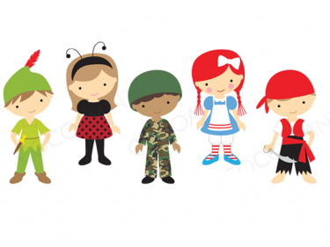 | 7  Family Day &  Library Grand Opening   | 8  Show and Tell
11 | 12 | 13  Math  Probability Quiz   | 14  Science  Energy Quiz   | 15
18  Book Report Due   | 19  Snack Sale   | 20  Book Report  Oral Presentation   | 21  Reading Comprehension Test   | 22  Class Party  Show and Tell  
25  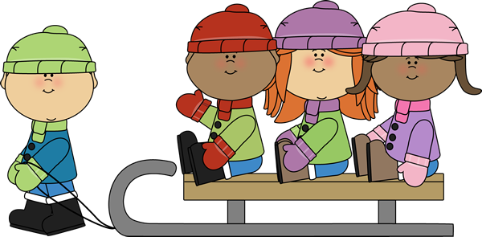 | 26  W I N T E R B R E A K | 27 | 28 | 29  

